WuWA
Wrocław Werkbund exhibition in Wrocław
Living and Work Space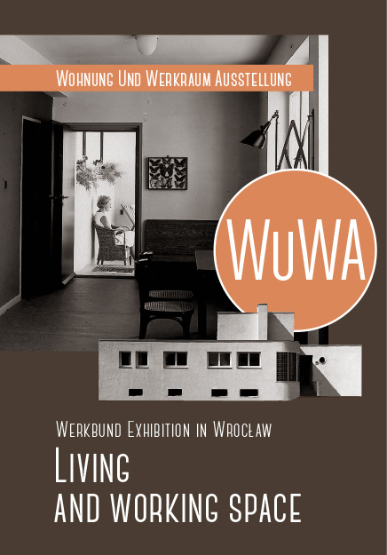

The most characteristic feature
of the WuWA housing estate is its variety of flats and houses for different social groups: the presented accommodation was conceived for both high and low-income users. The “house-community” project by Adolf Rading (house no. 7) or the hotel for singles and childless couples (house no. 31) are prime examples of the innovative solutions relating to the on-going discussion about which form that accommodation should take. In addition to this, new prevailing social tendencies concerning the professional engagement of women and the necessity to provide childcare resulted in the design and construction of a kindergarten and a small store for the estate.

The architects planned
the landscape for communal use and presented propositions for the development of the garden. Representatives of Housewives’ Association also actively participated in the preparation of the architectural concept and home decoration. The process of construction took only three months. The authors of the WuWA estate proved that new technologies and their appropriate application can bring new values, and demonstrated that artistic values and technical thinking are not mutually exclusive.

WuWA was one of the six model
housing estates by the Werkbund, built in Europe at the turn of the twenties of the last century. An innovative look at the urbanisation process, city overpopulation, and society’s expectations in terms of living conditions and ability to deliver the latest technologies in construction – these were the challenging aspects of the post-war period that urban planners and architects had to face. The model housing estates were to present a totally new approach, free from traditional thinking, in the field of construction which would change its users forever. These estates were an experiment of particular importance and its effects influenced the development of modern architecture of the twentieth century.

The WuWA housing estate was
a part of the “Living and Working Space” Exhibition, opened on June 15th, 1929. Adolf Rading and Heinrich Lauterbach were the authors of the urban planning concept. Particular houses were located in landscapes to provide the residents sufficient access to air, light, and sun. The houses were designed by architects belonging to the Silesian section of the Werkbund. Their aim was to create using easy-to-copy technologies, small and medium-sized flats which would be functional, comfortable, with central heating and running water, and at the same time available to an average consumer.

Thus the WuWA housing estate
is a unique complex of cultural heritage on a world scale. Luckily it has survived up till now in an almost unchanged condition. Besides its location near the Centennial Hall, the Zoo, Szczytnicki Park and the Japanese Garden, it makes for a very attractive tourist spot. In June 2014, the WuWA housing estate is celebrating its 85th anniversary, and even though it requires renovation, the very idea of a model housing estate is still fresh and is attracting lots of interest. What is more, the solutions presented by the authors are not only contemporary, but also inspirational for the youngest generations of architects and urban planners.

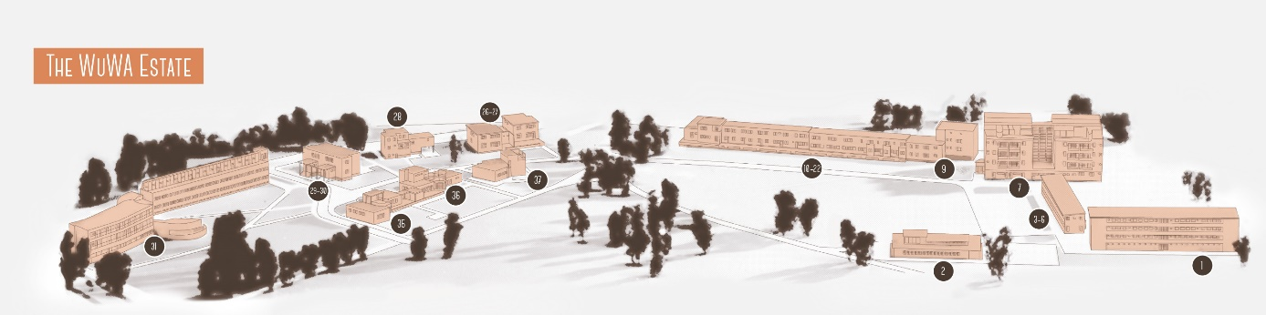

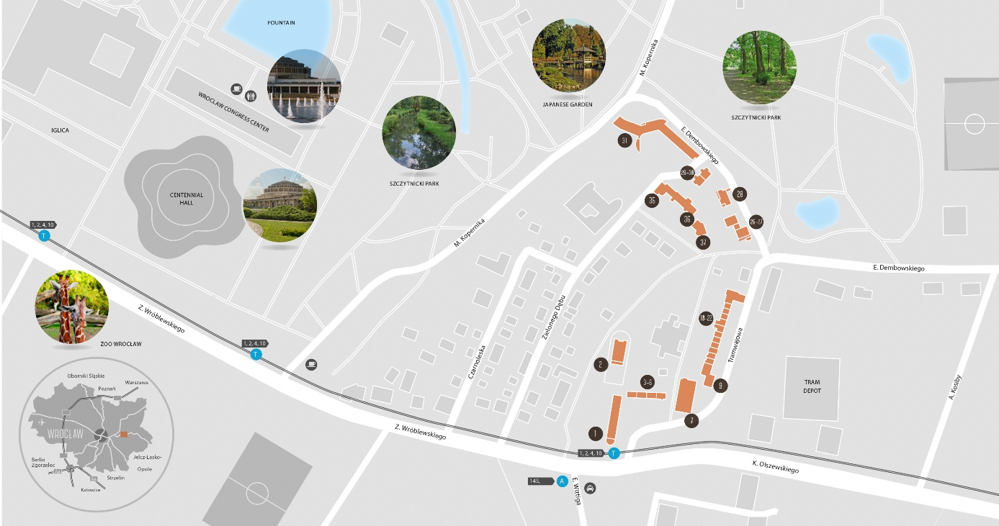

Gallery-access block of flats (1)
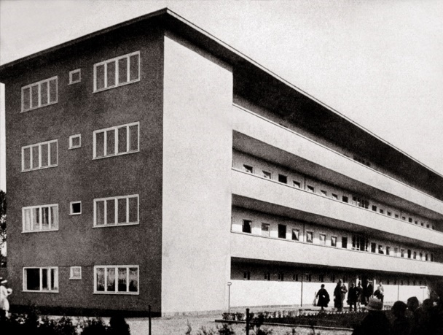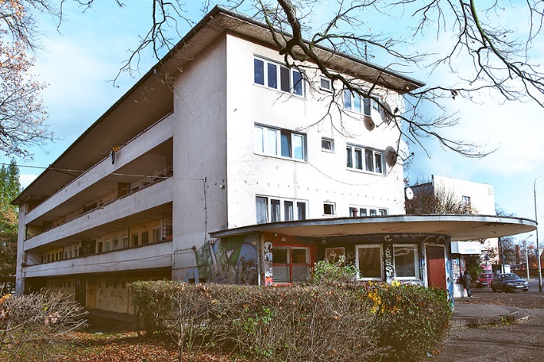
Address: No. 2 Tramwajowa Street
Surface area: 12 flats – 48 m2, 6 flats – 60 m2
Designers: Paul Heim (1879–1963), Albert Kempter (1883–ca.1941)
Construction: reinforced concrete framework filled with slag bricks
Current use: residential house

Kindergarten for sixty children (2)
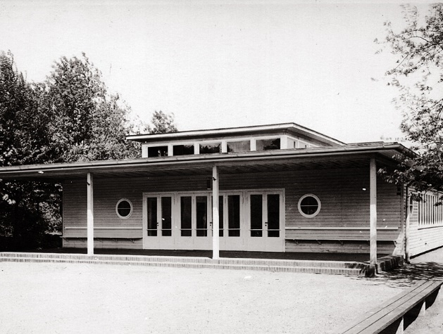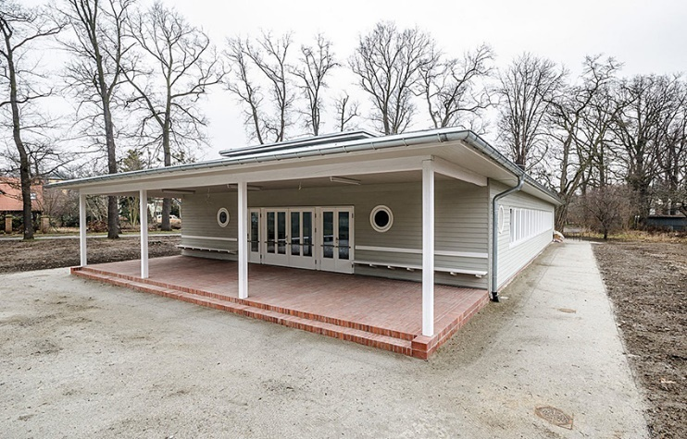
Address: No. 18 Wróblewskiego Street
Surface area: 296.3 m2
Designers: Paul Heim (1879–1963), Albert Kempter (1883–ca.1941)
Construction: “Doecker” system by “Christoph & Unmack A.G.” – system of prefabricated wooden panels for easy installation at the construction site
Current use: Burnt down in 2006, rebuilt in 2013 as the training center of the Lower Silesia Chamber of Architects.
Multi-family terraced house (3-6)
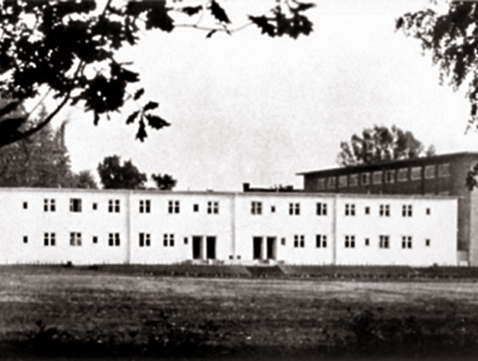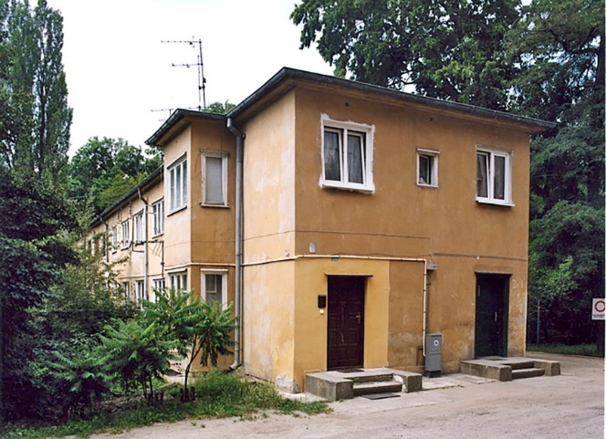
Address: No. 2a Tramwajowa Street
Surface area: 2 flats – 60 m2, 4 flats – 45 m2, 2 flats – 70 m2
Designer: Gustav Wolf (1887–1963)
Construction: timber framework (beams 10×12 cm) with internal and external “Heraklith” chipboard facing
Current use: residential house

Multi-family terraced house (7)
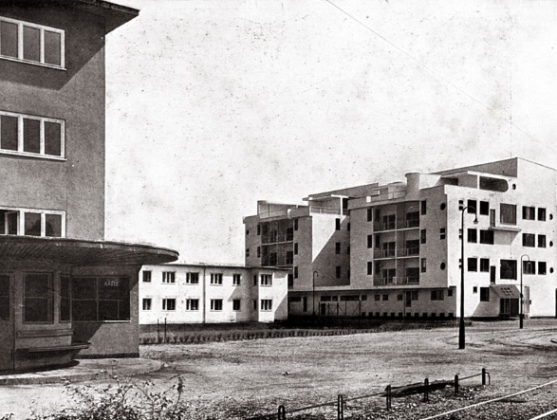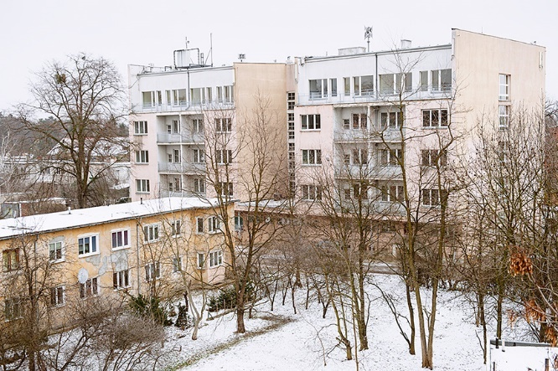
Address: No. 2b Tramwajowa Street
Surface area: 24 flats – 57 m2
Designer: Adolf Rading (1888–1957)
Construction: steel framework (space between the pillars 4×3.5 m) filled with “Schima” gas-concrete panels (16×30×50 cm)
Current use: The Wrocław University “Pancernik” halls of residents. The building was largely rebuilt.

Multi-family block of flats (9)
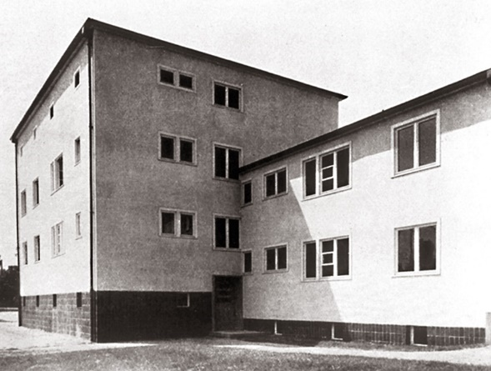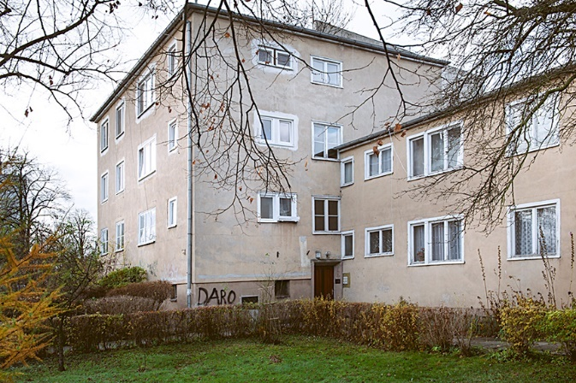
Address: No. 4 Tramwajowa Street
Surface area: 4 flats – 45.5 m2, 4 flats – 62 m2
Designer: Emil Lange (1884–1968)
Construction: “Spiegel” steel framework filled with gas concrete “Schima” panels (50×30–40×15 cm)
Current use: residential house

Single-family terraced houses (10-22)
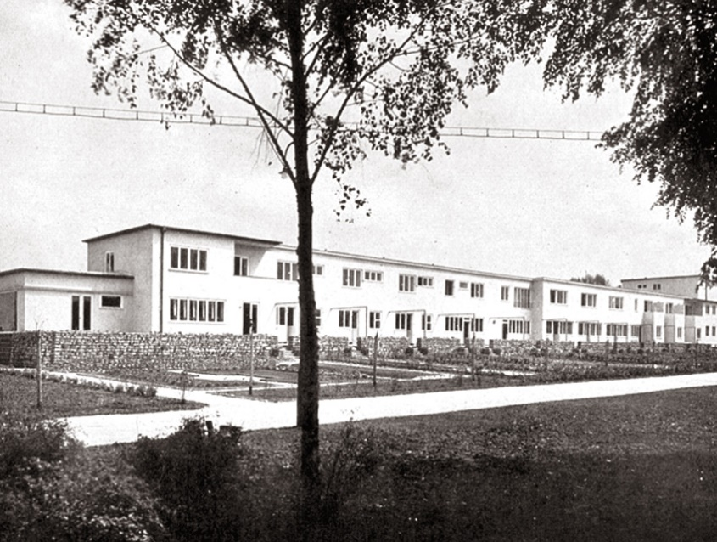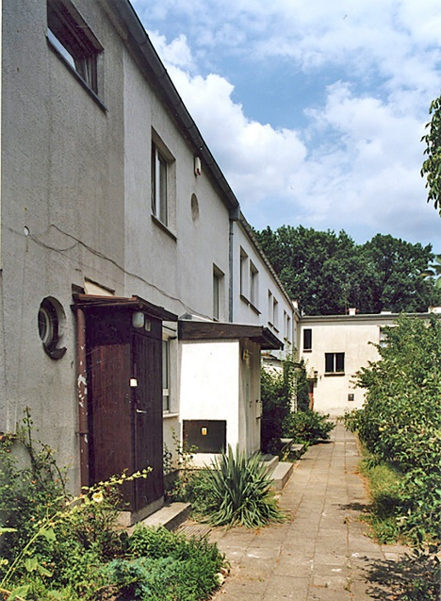
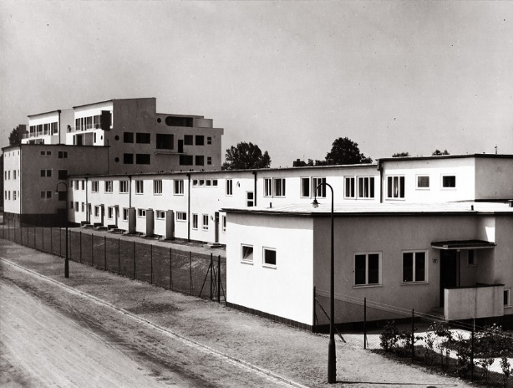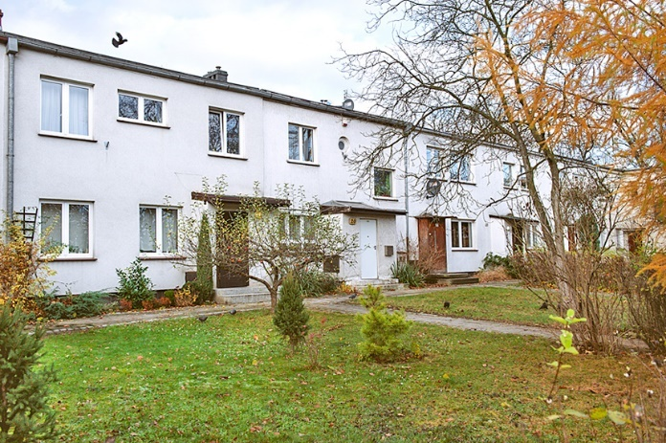
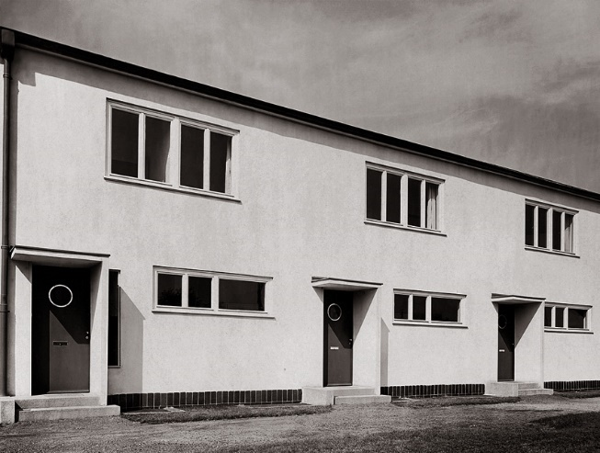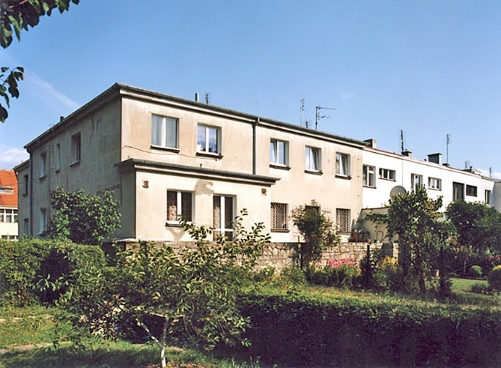
Address: No. 6–30 Tramwajowa Street
Surface area: 3 flats – 86 m2 (no. 10–12), 3 flats – 91 m2 (no. 13–15), 2 flats – 86.07 m2 (no. 16–17), 3 flats – 78 m2 (no. 18–20), 1 flat – 148.86 m2 (no. 21), 1 flat – 94.2 m2 (no. 22)
Designers: Ludwig Moshamer (no. 10–12), Heinrich Lauterbach (no. 13–15), Moritz Hadda (no. 16–17), Paul Häusler (no. 18–20), Theo Effenberger (no. 21–22)
Construction: reinforced concrete framework filled with cellular concrete hollow bricks (12×14×25 cm) (no. 10–12), wall constructed of slag bricks (load bearing walls between the sections, 25 cm thick) (no. 13–15), reinforced concrete framework filled with 25 cm thick ferro-concrete hollow bricks (no. 16–17), ceramic brick wall, 25 cm thick (no. 18–20), “Kilgus” technology – two vertical slag concrete panels with a gap between them, in places of greater load-bearing, walls filled with concrete and steel inserts (no. 21–22)
Current use: residential houses

Semi-detached house with garages (26-27)
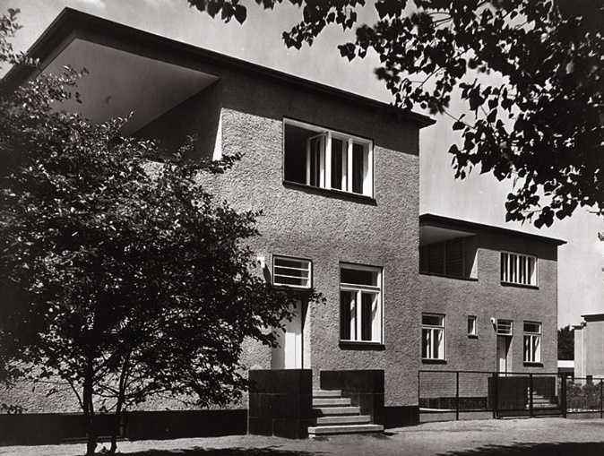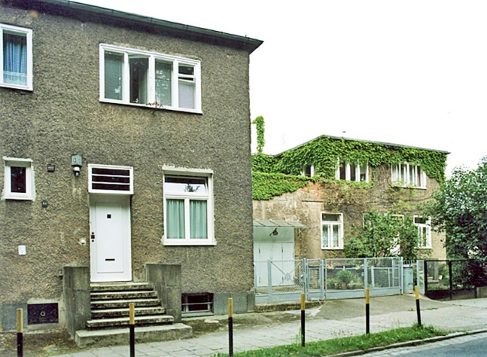
Address: No. 11–13 Dembowskiego Street
Surface area: 2 flats – 185 m2
Designer: Theo Effenberger (1882–1968)
Construction: “Leipziger” technology – two skinned walls constructed of hollow bricks and concrete “Portophor” tie bricks
Current use: residential house

Detached house with garages (28)
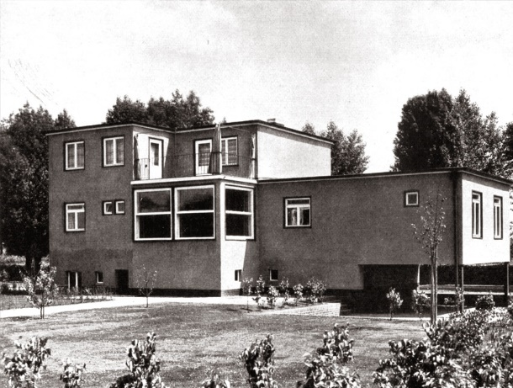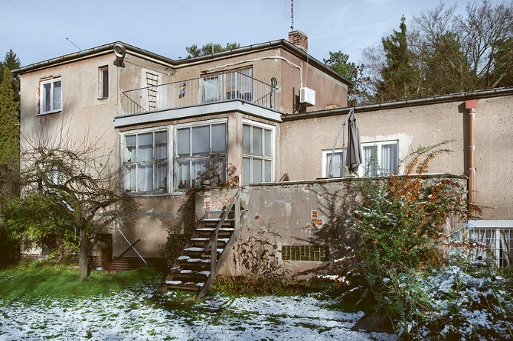
Address: No. 9 Dembowskiego Street
Surface area: 149 m2
Designer: Emil Lange (1884–1968)
Construction: steel framework filled with 17 cm thick gas concrete “Schima” panels
Current use: residential house

Semi-detached house (29-30)
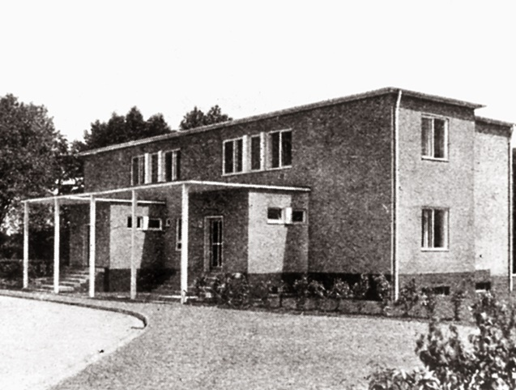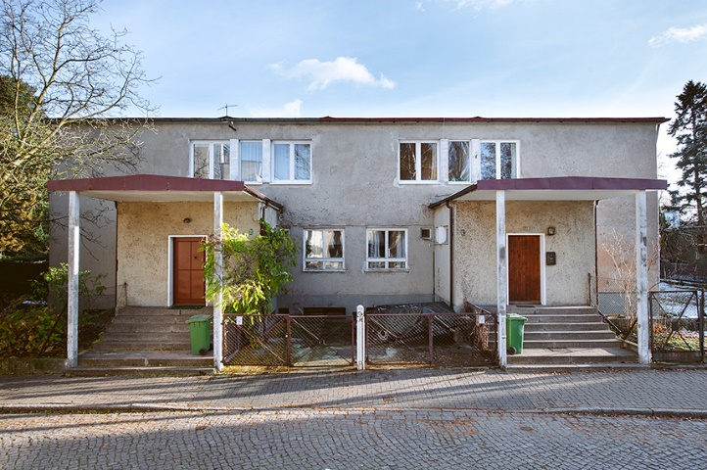
Address: No. 23–25 Zielonego Dębu Street
Surface area: 2 flats – 148 m2
Designer: Paul Häusler (date unknown)
Construction: two layer, 44 cm thick brick (25×12 cm) wall, gap between two layer brick skins filled with slag
Current use: residential house

The hostel for singles and childless couples (31)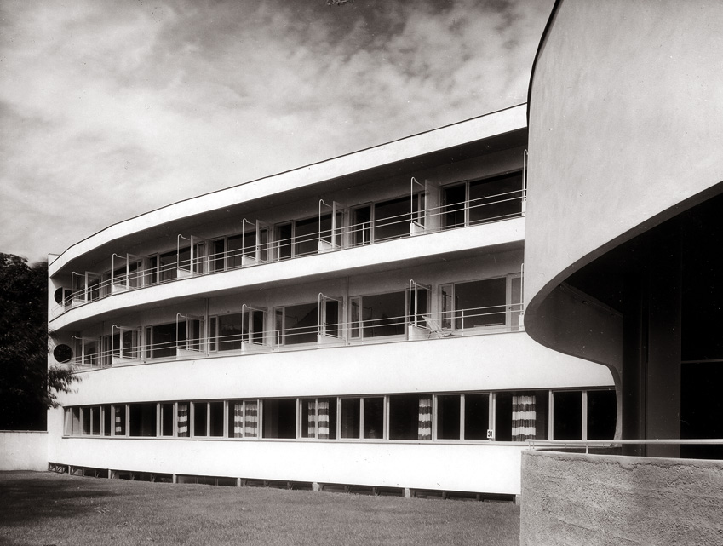 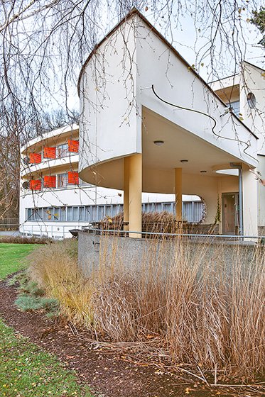
Address: No. 9 Kopernika Street
Surface area: 16 flats – 37 m2, 32 flats – 27 m2
Designer: Hans Scharoun (1893–1972)
Construction: ferro-concrete framework (“house of cards” type – “Karteblattbauweise”), applied on “wet”, spaces between frame pillars 3 m and 3.5 m
Current use: hotel

Detached house (32-33)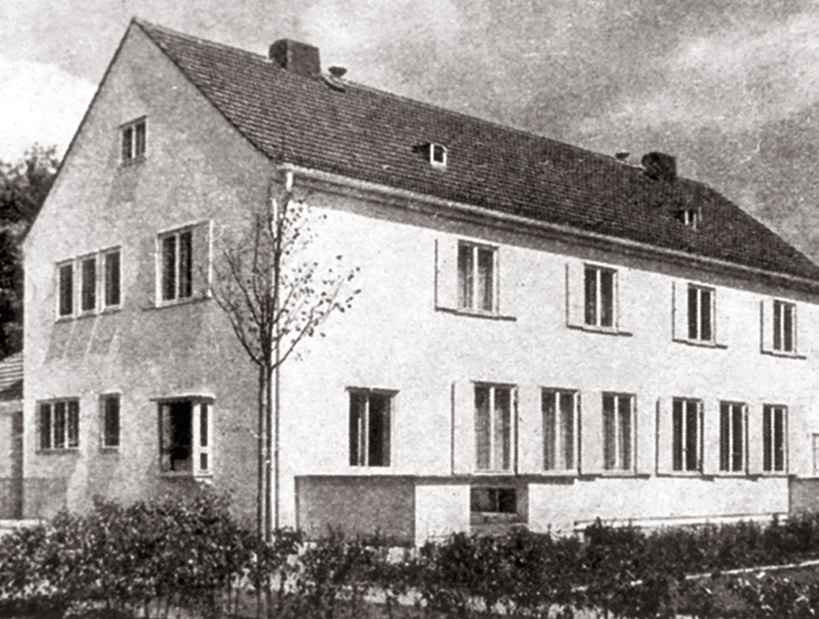
Address: No. 7/8 Kopernika Street
Surface area: 165 m2 and 189 m2
Designer: Gustav Wolf (1887–1963)
Construction: timber framework with inner and outer chipboard “Tekton” facing
Current use: non-existent

Detached house (35)
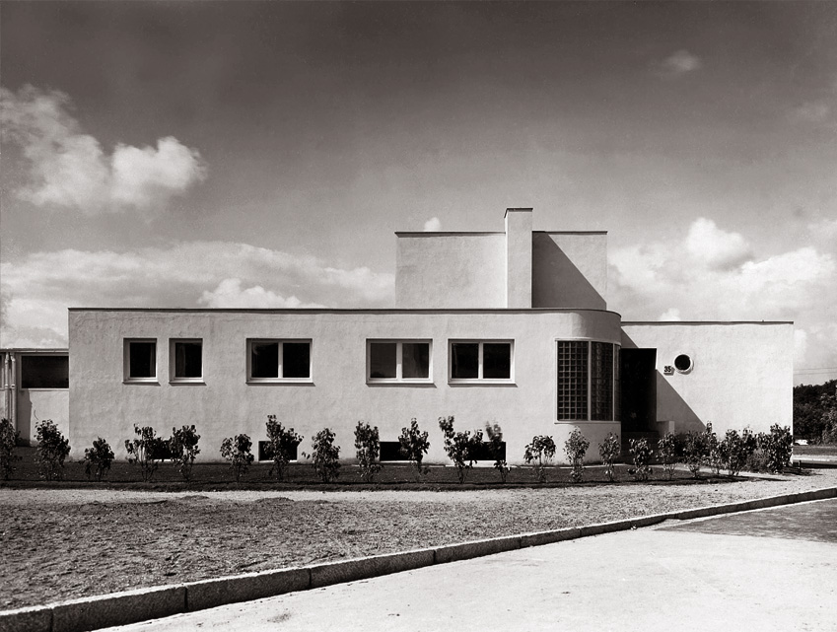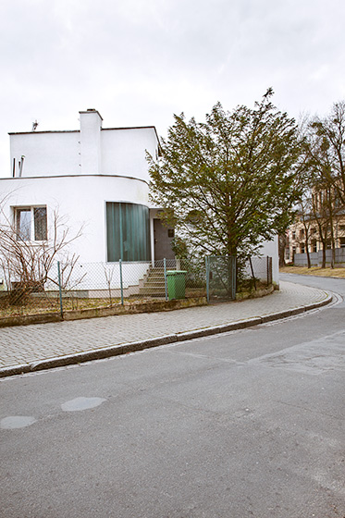
Address: No. 17 Zielonego Dębu Street
Surface area: 180 m2
Designer: Heinrich Lauterbach (1893–1976)
Construction: 44 cm thick brick wall
Current use: residential house

Detached house (36)
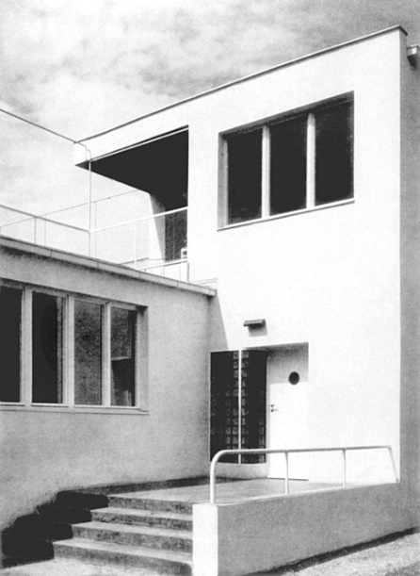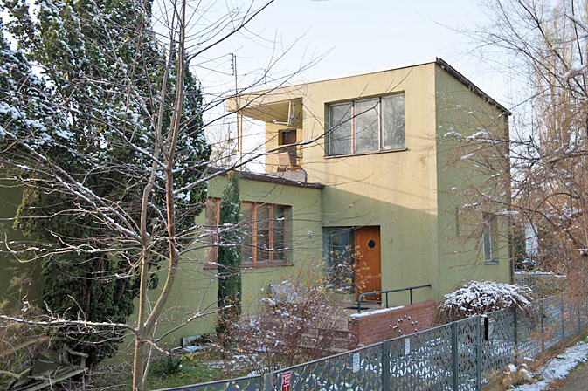
Address: No. 19 Zielonego Dębu Street
Surface area: 202 m2
Designer: Moritz Hadda (1887–ca. 1942)
Construction: two layer, 44 cm thick brick wall
Current use: residential house

Detached house (37)
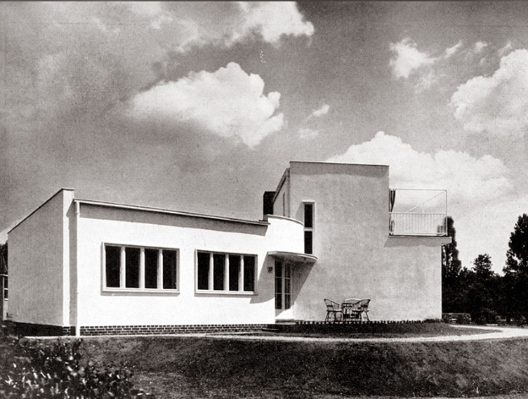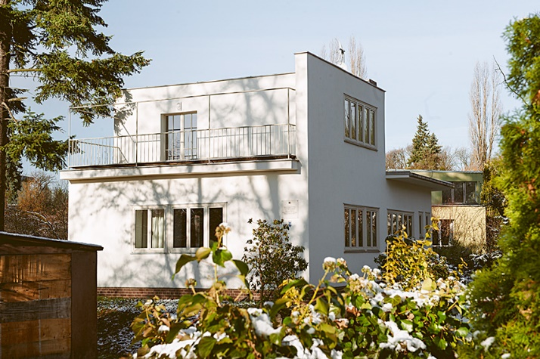
Address: No. 21 Zielonego Dębu Street
Surface area: 149 m2
Designer: Ludwig Moshamer (1885–1946)
Construction: two layer, 44 cm thick brick wall
Current use: residential house

